Navn: ____________________________________

Eta gras
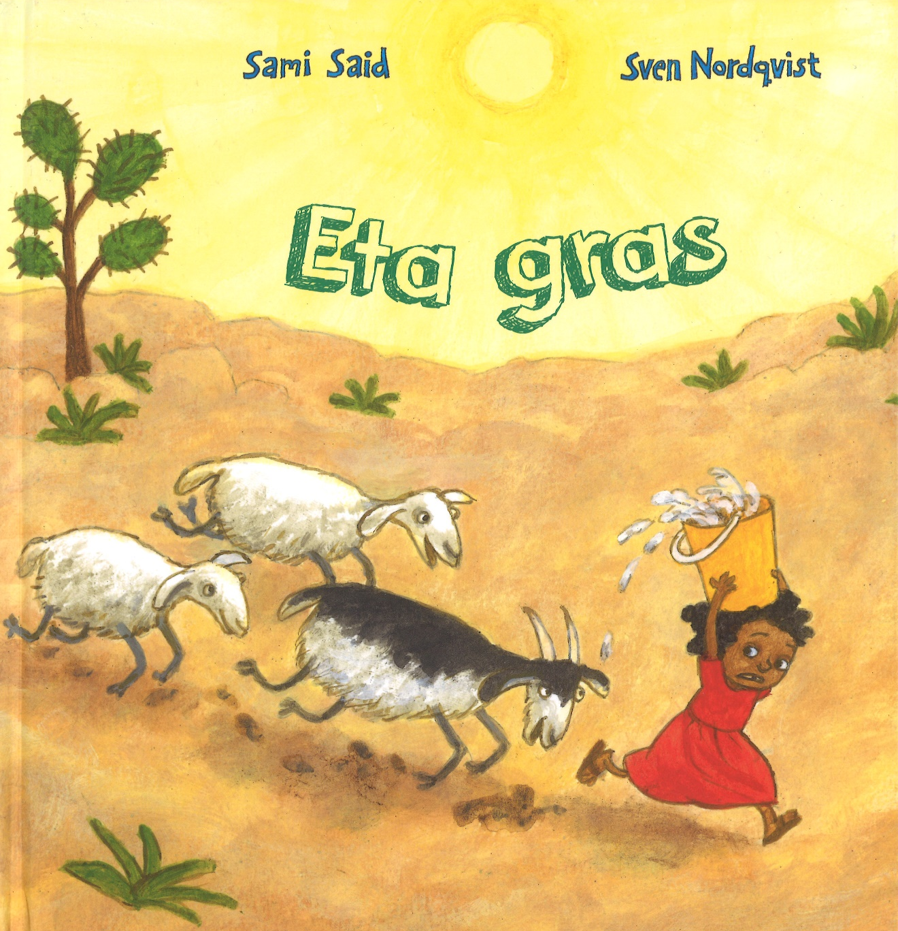
Uppgávur

Rithøvundur Sami Said
Teknari Sven Nordqvist
Bókadeild Føroya Lærarafelags 2020
Navn: ____________________________________

Perma
Tekna eina skitsu av permuni. Skriva trý orð, sum lýsa permuna.

__________________________ __________________________ __________________________

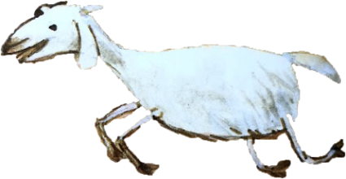
Navn: ____________________________________

Títt lív
Hvørjum húsligum arbeiði hjálpir tú við heima? Er nakað húsligt arbeiði, sum tú ikki tímir serliga væl at gera? Er nakað, sum kundi gjørt tað lættari/stuttligari? Skriva orð ella tekna myndir í kassan, sum vísa títt svar.

Navn: ____________________________________

Hygg at myndunum – meira um bókina
Hygg at permuni og brúka so eina løtu at hyggja at myndunum í bókini. Royn síðan og svara spurningunum á síðuni. Tú kanst skriva ella tekna í kassarnar.
Heitið | Rithøvundur
 | Teknari
Hvat heldur tú, at bókin er um?
Hvønn heldur tú, at bókin er um?

Navn: ____________________________________

Hygg at myndunum – meira um bókina
Tekna eina mynd av tí opnuni, sum tær dámar best. Skriva eitt sindur um, hvat tær dámdi við myndini, og hví tær dámar myndina.
_________________________________________________________________________________________________________________________________________________________________________________________________________________________________________________________________________________________________________________________________________________________________________________________________________________________________________

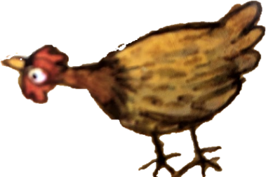
Navn: ____________________________________

Eg undrist ...
At spyrja undrandi spurningar um tað, sum tú lesur, kann hjálpa tær at skilja tað.
Nú hevur tú havt møguleika at hyggja ígjøgnum bókina/lesa bókina. Her eru nakrir spurningar, sum tú skalt gera lidnar.
Eg undrist á hvør ______________________________________________________
__________________________________________________________________________________________________________________________________________
Eg undrist á nær _______________________________________________________
__________________________________________________________________________________________________________________________________________
Eg undrist á hvar _______________________________________________________
__________________________________________________________________________________________________________________________________________
Eg undrist á hví ________________________________________________________
__________________________________________________________________________________________________________________________________________
Eg undrist á hvussu ____________________________________________________
__________________________________________________________________________________________________________________________________________

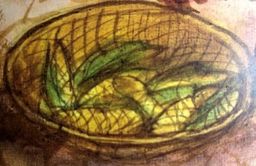
Navn: ____________________________________

Eta gras – spurningar
Hvat sigur Imani Lillian Mau, at hon dugir væl? ______________________________
_____________________________________________________________________
__________________________________________________________________________________________________________________________________________
Hví er tað vandamikið at fara eftir vatni? ___________________________________
__________________________________________________________________________________________________________________________________________
Hvussu er, tá ið tað er turt, har Imani býr? __________________________________
__________________________________________________________________________________________________________________________________________
Hvussu er, tá ið tað er regnflóð, har Imani býr? ______________________________
__________________________________________________________________________________________________________________________________________
Hví heldur tú, at bókin eitur Eta gras? ______________________________________
_______________________________________________________________________________________________________________________________________________________________________________________________________________

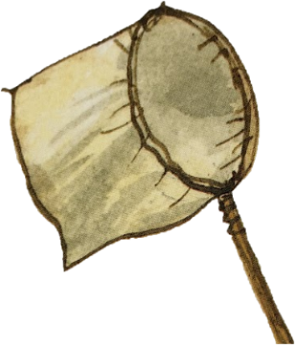
Navn: ____________________________________

Imani Lillian Mau og tú
Hugsa um, hvussu Imani Lillian Mau og tú líkjast, og hvussu tit ikki líkjast.

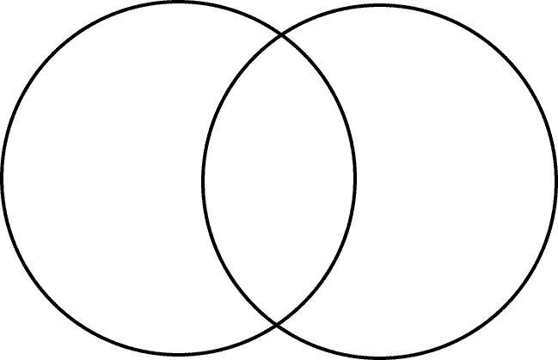
Imani Lillian Mau

líkjast

tú

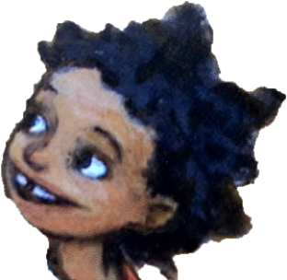
Navn: ____________________________________

Søgukort
Hugsa um søguna Eta gras. Fyll søgukortið út.

Persónar | Umhvørvið
Trupulleiki/Trupulleikar | Loysn/Loysnir

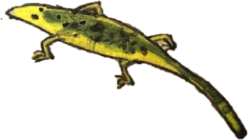
Navn: ____________________________________

Týdningarmiklar hendingar í søguni
Vel fýra hendingar úr søguni Eta gras og tekna tær. Minst til at tekna tær í rættari raðfylgju.

1. 2.

3. 4.
Navn: _____________________________
Søgan og eg
Skriva um okkurt, sum tú setur í samband við Eta gras og títt egna lív.

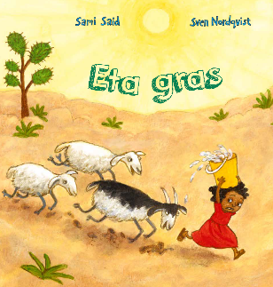
________________________________________________
________________________________________________
________________________________________________
________________________________________________
_____________________________________________________________________
_____________________________________________________________________
_____________________________________________________________________
____________________________________________________________________________________________________________________
_______________________________________________
_______________________________________________
_______________________________________________
_______________________________________________
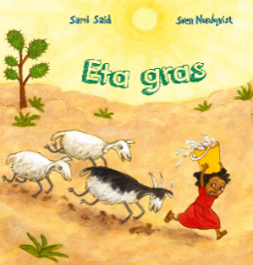
Navn: _____________________________

Søgan og aðrar søgur
Skriva um okkurt, sum tú setur í samband við Eta gras og aðrar søgur, sum tú hevur lisið.
Søgan minnir meg um hesa bókina.
_____________________________________________________________________
Samanber Eta gras og søguna tú nevnir.
_____________________________________________________________________
_____________________________________________________________________
_____________________________________________________________________
_____________________________________________________________________
_____________________________________________________________________
_____________________________________________________________________
________________________________________________
________________________________________________
________________________________________________
________________________________________________
Navn: _____________________________
Søgan og heimsmálini
Tekna og skriva, hvussu tú heldur Eta gras hóskar saman við teimum 17 heimsmálunum.
_________________________________________________________________________________________________________________________________________________________________________________________________________________________________________________________________________________________________________________________________________________________________________________________________________________________________________

Navn: _____________________________

Alt um Imani Lilliuna Mau
Í søguni Eta gras fáa vit ymiskt at vita um Imani Lilliuna Mau. Skriva orð um Imani í rundingarnar á síðuni.

Navn: _____________________________
Nýggj perma
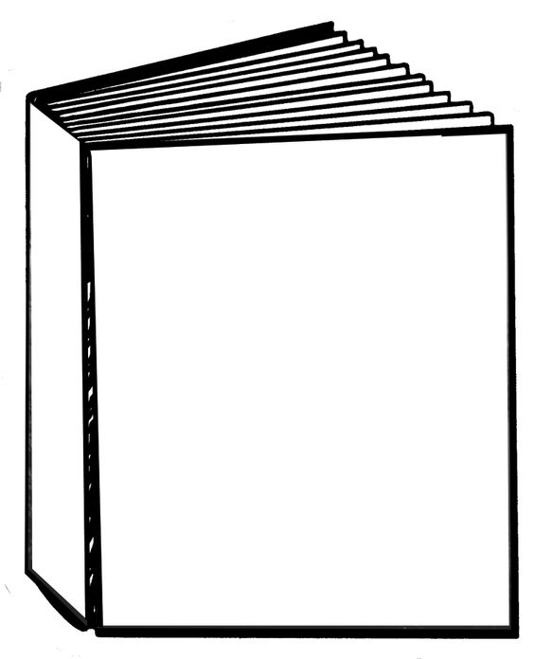
Tekna eina nýggja permu til bókina Eta gras.

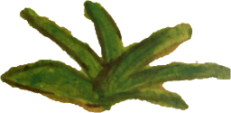
Navn: _____________________________

Hvussu eg kann hjálpa heima hjá okkum
Í Eta gras hjálpir Imani Lillian Mau mammu síni við at fara eftir vatni. Hugsa um, hvussu tú kundi hjálpt til heima hjá tykkum. Skriva trý hugskot.
1. hugskot: ___________________________________________
____________________________________________________________________________________________________________________________________________________________
2. hugskot: ___________________________________________
____________________________________________________________________________________________________________________________________________________________
3. hugskot: ___________________________________________
____________________________________________________________________________________________________________________________________________________________
Navn: _____________________________
Eta gras 3 – 2 – 1

3  hendingar  mær dámar | _________________________________________________  _________________________________________________  _________________________________________________  _________________________________________________  _________________________________________________
2  hendingar  eg ynski at broyta | _________________________________________________  _________________________________________________  _________________________________________________  _________________________________________________  _________________________________________________
1  spurningur  eg havi til søguna | _________________________________________________  _________________________________________________  _________________________________________________  _________________________________________________  _________________________________________________
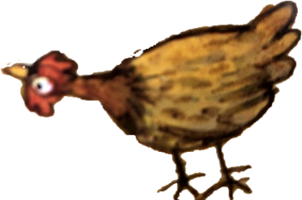
Navn: _____________________________

Finn orð

N | O | K | G | E | I | T | I | R | S | Ó | F
A | L | H | L | U | B | E | F | J | Ó | Ð | U
M | M | O | Ú | V | D | G | S | U | L | A | G
A | A | R | P | H | Ó | N | P | R | Y | M | L
I | M | N | U | Í | G | R | A | N | N | I | A
S | M | O | R | B | R | U | N | N | U | R | S
V | A | T | N | S | E | B | N | A | M | E | K
E | F | S | K | Ý | K | L | O | D | D | I | R
L | F | J | A | L | L | I | Ð | N | E | V | Í
T | U | R | K | U | R | I | M | A | N | I | M
A | V | A | T | N | F | L | Ó | Ð | U | P | S
L | I | S | Ó | L | M | A | G | N | E | T | L

BRUNNUR
FJALLIÐ
FUGLASKRÍMSL
GEITIR
GLÚPUR
GRANNI
HORN
IMANI
MAISVELTA
MAMMA
SKÝKLODDI
SÓL
SÓLMAGNET
SPANN
TURKUR
VATN
VATNFLÓÐ

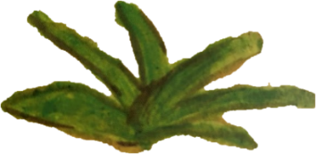
Navn: _____________________________

Ummæli
Lita so nógvar stjørnur, sum tú vilt geva bókini Eta gras. 1 stjørna = ikki serliga góð, 5 stjørnur = øgiliga góð. Skriva síðan, hvat tú heldur vera tað besta við bókini.

__________________________________________________________________________________________________________________________________________________________________________________________________________________________________________________________________________________________________________________________________________________________________________________________________________________________________________________________________________________________________________________________________________________________________________________________________________________________________________________________________________________________________________________

